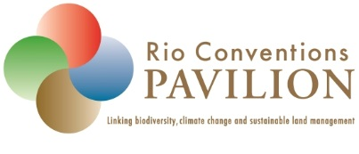 | Highlights of the Rio Conventions Pavilion UNCCD COP 14 | 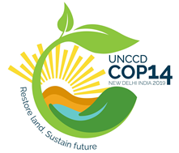
5 September 2019

SCIENCE DAY / THE GEF EVENING

Highlight 1: Science Day
The Science-Policy Interface (SPI) of the UNCCD, with technical support of the UNCCD Secretariat, organized Science Day at Rio Conventions Pavilion. The Day aimed at providing a forum for scientists, policy makers and other stakeholders sharing information and knowledge through presentations, expert statements and interactive discussions on support for planning and implementation of land degradation neutrality (LDN) at country level.
The diverse and highly-engaged audience included scientists, policy-makers, practitioners, students, journalists and representatives of CSOs, NGOs and development agencies. Speakers emphasised the interconnections between land and climate, and the multiple benefits to nature and humans from sustainable land management.

Session 1: Overview
The Day was opened by UNCCD Deputy Executive Secretary Pradeep Monga and Annette Crowie, SPI member and lead author of IPCC Special Report on Climate Change and Land.
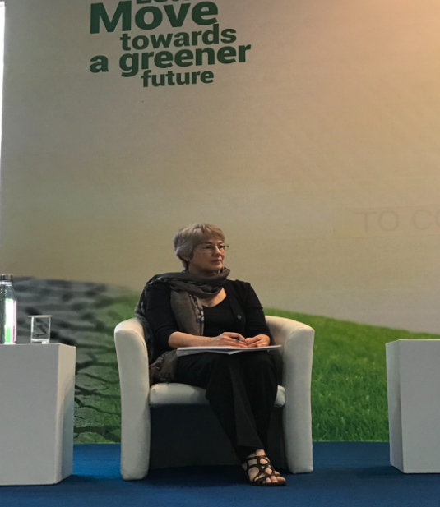
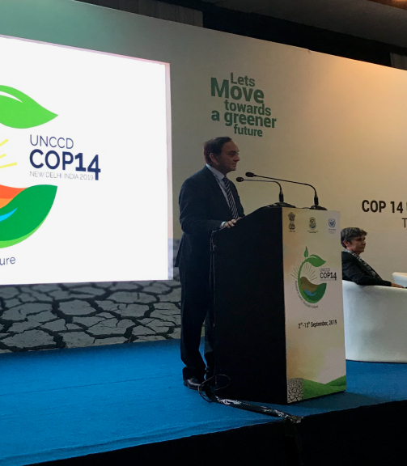
Stressing the significance of Science Day, Dr. Monga said it is an important time to invest in land because Sustainable Land Management is a key component to ensure food security and other basic amenities.
According to him, land is the integrator and accelerator of all SDGs. “Unless we take care of the land, we won’t achieve SDGs”, he said.
Dr. Cowie, Lead Author of IPCC Special Report on Climate Change and Land, stressed the need of swiftly addressing land degradation issues as it has great impact on the productivity of land. We need preparatory activities to combat land degradation and plan now to achieve, avoid, reduce and reverse land degradation. She also stressed the need for indicators to measure LDN status and use social indicators that are relevant to the context, including principles for LDN implementation.

Session 2: Introducing the IPCC Special Report on Climate Change and Land
The opening was followed by the special session by the authors of the IPCC
Special Report on Climate Change and Land.

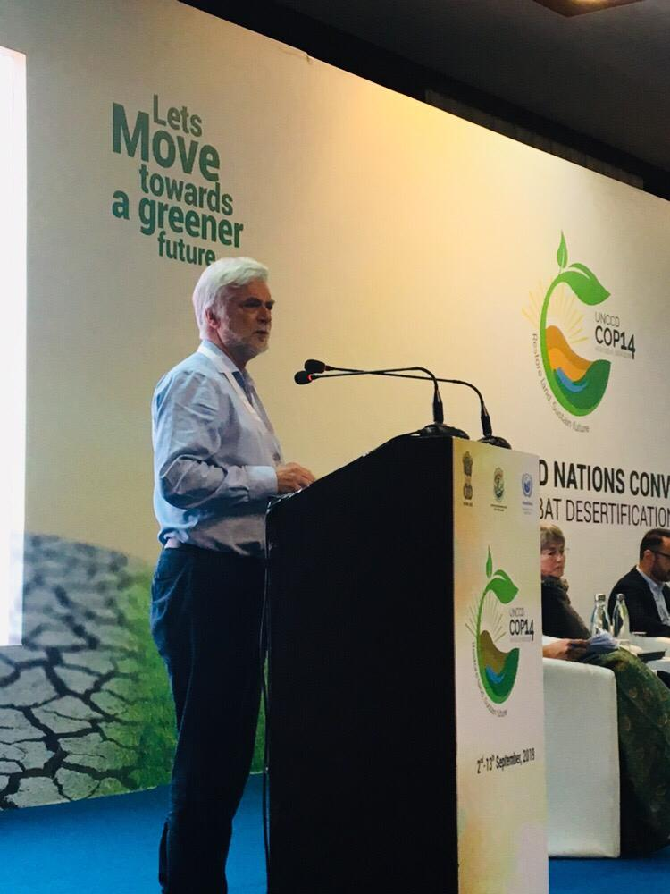
Jim Skea (Co-Chair, working Group III of IPCC) said that IPCC received six proposals for land related special reports at the start of the sixth assessment cycles. He observed that food security issue is neglected in the assessment and urged everyone to put more attention to the interaction between climate and land rather than focus on all issues related to land.

Minal Pathak (Technical Support Unit Working Group III, Drafting Author, SPM) said land degradation is a driver of climate change through emission of greenhouse gases and reduced rates of carbon uptake.
Human-induced global warming has already caused observed changes in two drivers of land degradation - increased frequency, intensity and/or amount of heavy precipitation, and increased heat stress.He also noted that global warming beyond that of present-day will further exacerbate ongoing desertification and land degradation processes through increasing floods, drought frequency and severity, intensified cyclones, and sea-level rise, with outcomes being modulated by land management.
Dr. Pathak further said increase in food production has not benefitted the marginalized people. The loss of soil carbon is one of the major reasons for land degradation. She felt that sustainable food production could bring about huge changes in farming practices thereby reducing the threat of land degradation. She emphasized the importance of empowering women for inclusive action on LDN.
Alisher Mirzabaev (Coordinating Lead Author of the IPCC report) drew attention to the fact that 1.5-3.2 billion people reside in land degradation areas. 500 million people in dry land areas experience desertification in an intense way. Since 1961 annual dry land areas have decreased by 1%. She said that aridity and climate change are two different concepts and it is necessary to recognize them as such. She drew attention to the alarming statistics of soil erosion rate, which stands at almost hundred times higher than the rate of soil formation. Land degradation is the driver of climate change. Technologies are not enough to arrest this. We need enabling actions on desertification, she said. It is imperative that we implement LDN.
She further noted that climate change and land degradation have the following important co-relations: (1) achieving CC adaptation and mitigation without land is not possible; (2) achieving LDN without CC considerations is not possible; and (3) the pursuit of LDN provides incentives to achieve CC adaptation and mitigation.
The introduction of the report was followed by the panel discussion by the report authors. Jagdish Krishnaswamy (Coordinating Lead Author, IPCC report) said that drylands are on the increase. How we use land is both the problem as well as the solution. He also discussed the criteria for defining the magnitude of impacts which are mitigation, adaptation, desertification, food security and land degradation. Land based solutions have the potential to reduce the risks of warming and help with adaptation options to live with climate change.

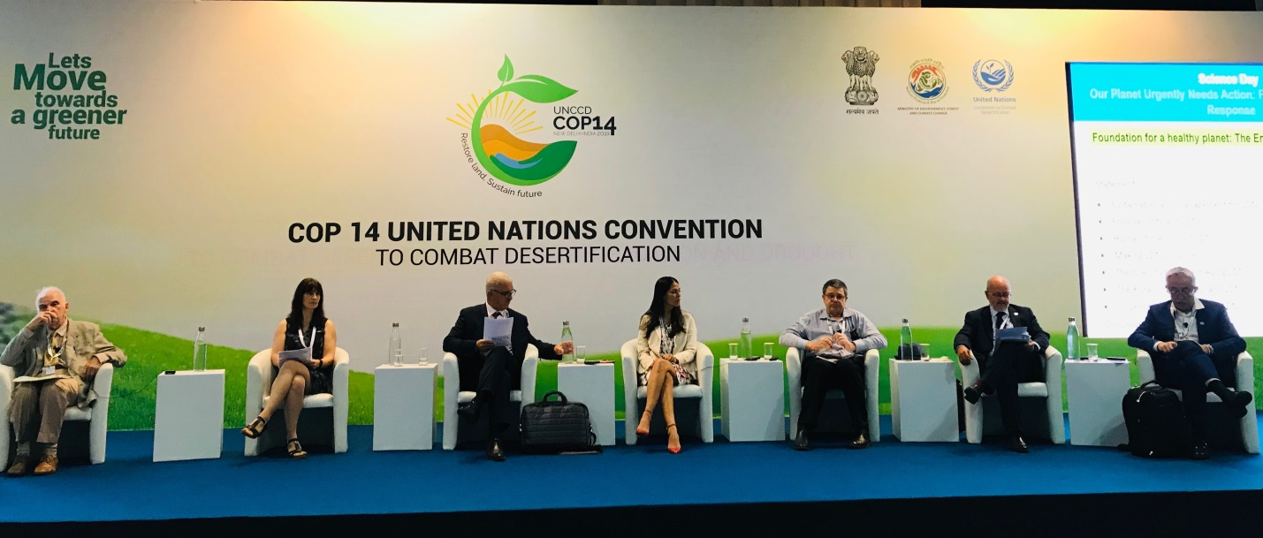
Panelists discussing the IPCC special report on climate change and land

Session 3: Foundation for a healthy planet: The Enabling Environment for LDN
The session composed of a series of brief interventions by the speakers on different dimensions on creating the enabling environment for LDN. It was facilitated by Nichole Barger (Member, Science Policy Interface).
- Lindsay Stringer (IPCC Special Report lead author, University of Leeds) said LDN is more about managing people than land. She stressed the importance of securing land tenure for people and to achieve LDN.
- Jean-Luc Chotte (Soil scientist, ORSTOM) spoke about Sustainable land management for LDN, in which he pointed out that there is no one-fits-for-all SLM solution.
- Eduardo Mansur (Director of the Land and Water Division of FAO) said in order to produce food for all and achieve SDG 2, we have to take into account change of food consumption habit, more jobs creation for food production and sustainable use of land.
- Mariody Sanchez Santivanez (Asociacion para la Investigacion y Desarrollo Integral) explained that inclusion is not only about more participation but it is to enable participation of all the stakeholders in LDN process. We need to explore mechanism that improves inclusion, she said.
- Youssef Brahimi (President, DesertNet International) talked about the role of Civil Society Organisations (CSO), which should be politically recognized. CSO has holistic vision of LDN. He stressed the importance of taking social economic actions.
- Graham von Maltitz (Council for Scientific and Industrial Research) said urban population is continuously increasing and Africa will be seeing urbanization at unprecedented level. He stressed the importance of urban people to change their lifestyles.
- Poonam Dabas (Environment Journalist) said we have been too far obsessed with the economic growth. The most important decision should be to restore land degradation. India is committed to achieving LDN by 2030 and policies are undertaken and results have been good so far.
- Andre Francisco Pilon (University of São Paulo) said challenges are more civic and political than technical. To create collaborative ecosystem partnerships and international restoration targets, it is important to consider the different kinds of biomes and land exploration.
Six experts from the panel posed a question to groups in the audience and sat with the groups to have a discussion on the questions that were posed during the session. And the findings are enumerated below:

Group 1
- Issue of land is specific to each country
- Diversity of food
- Restore degraded land
- Challenge to increase productivity for sustainable intensification

Group 2

- Academia and CS O– how can state actors play an active role in LDN
- Who are state and non-state actors
- Make active role to bring trust between gov and themselves
- CSO have data – government can take that data into account
- Bringing about LDN – to have a forum to bring awareness and trust which needs to be translated into action

Group 3
- How can scientists support development of good governance
- Indicator and systems approach
- Sectoral issue to be overcome by integrated approaches
- Resilience

Group 4
- What is recognition of CSO (global and regional)
- Capacity building

Group 5
- To use agroforestry systems oceans, rivers, wetlands
- Enabling policies at regional levels and including industries in these enabling policies

Group 6
- How can multiple benefits of SLM guide LDN
- How SLM best practices are communicated to small land-holders
- Outreach to farmers should be done in local languages
- To provide a knowledge basis to the last mile
- How to speed up If LDN is well-known can we still use LDN in different languages.
- Landscape restoration is a choice of society and people, interests of communities to be taken into account
- Introduce subsidies for organic to be more affordable so that it contributes to Balance within value chain so that rural population Organic ag should be taken into consideration

Session 4: Tools and practices to achieve multiple benefits through LDN
The session was introduced by Jim Skea (Co-Chair, IPCC Working Group III) who comment the significance of the IPCC chairing an SPI session which was a testimony to seamless collaboration between the two well-known entities.
The speakers of the session were: Ermias Betemariam, Eleanor Campbell, Marijana Kapovic Solomun, Mark Svobodo, and Nichole Barger who deliberated on the following points.
- Ermias Betemariam on soil carbon-a key indicator for LDN: He said that soil organic carbon (SOC) gives life to soil and is pivotal to multifunctional benefits. On the question of how we achieve large scale adoption of SLM practices and landscape restoration, Ermias proposed the following: (1) evidence by monitoring progress & learn for adaptive management; (2) engagement by targeted multiple benefits practices that sequester enhance productivity, biodiversity, etc.; (3) outreach by stimulating and coordinating better communication between scientists, businesses, public and private enterprises, policymakers and the public.
- Eleanor Campbell on tools for soil carbon estimation: Ms. Campbell stressed on the need for an overall SOC assessment to achieve SLM and strategic investment in soil carbon management. One must make best use of existing information to select the best practice. It is advisable that high level of uncertainty be avoided in soil carbon management.

- Peter Verburg on integrated land use planning to reconcile sustainable use and conservation: Mr.Verburg said achieving LDN and implementing sustainable development are largely a land governance challenge. We must reduce pressure on land (IPCC Land Report), integrated land use planning and optimize multiple objectives. Science can contribute to Integrated Land Use Planning (ILUP) by reducing the carbon impact on land in a scientific way.
- Marijana Kapovic Solomun on measures to avoid, reduce and reverse land degradation: Ms.Solomun stressed the need for SLM at all levels-global, national, regional and individual and spoke about what different measures to adopt for different land types. She was of the opinion that farmers should be given the knowledge to improve their soil health to increase land fertility. Often modern knowledge on SLM is not accessible to farmers.
- Mark Svoboda on the land-drought nexus and drought-smart solutions: Mr.Svoda said that the health and well -being of 3.2 billion are directly or indirectly impacted by land degradation and drought. The main objective of drought-smart solution is to improve soil capacity to accept, retain and transmit water and also to increase capacity of land to hold water within. There is now an improved understanding of the relationship between land management and drought smart solutions. He further added that mitigating the effect of drought on ‘proactive drought management’ has increased the resilience of people and eco -systems to drought.
- Nicole Barger on connecting consumptions and productions to create sustainable supply chains: Ms.Barger said that rising population and developing economies are the main reasons for land degradation and over consumption is driven by over population. It is important to create more awareness on consumption choices to create sustainable supply chains. LDN can be enhanced through improving current and existing mechanism.

Session 5: The diagnosis: Scientific assessment to inform policy

The session composed of a series of brief interventions by the speakers who addressed on how scientific assessments could help govern policy. It was facilitated by Barron Joseph Orr, Lead Scientist, UNCCD.
The welcome address to the session was delivered by Ibrahim Thiaw. Read statement

The speakers for the session were : Jeffery Herrick ,Micheal Cherlet, Josef Settele, Fatima Denton, Jagdish Krishnaswamy, Douglas Cripe, who deliberated on the following points.
- Jeffery Herrick on land restoration and sustainable development: Mr Herrick stressed the need of addressing wide range of issues including the land framework based on “avoid, reduce and reverse” sequence, taking integrated landscapes approach. He proposes policy solutions to challenges posed by resource depletion and misuse. Land restoration and rehabilitation together represent one of three primary strategies for achieving SDG 15(Life on Land). The co-benefits of the restoration process are often much different than those of the restore land and often work at different temporary scales.
- Michael Cherlet on convergence of evidence: Mr Cherlet stressed the importance of linking climate change and land, as humans drive global change processes. She explained that land degradation is local process with global repercussions and how we need to bring different information and indicators together and then integrate them. The convergence of evidence approach is to collect multiple, independent source of evidence. The principles of convergence of evidence states that no Global Change Issues (GCI) by itself is sufficient to land degradation but if multiple GCI’s were to occur at any location, this whole suggest potential for Land Degradation(LD).
- Josef Settele on land, biodiversity and ecosystems services: He stated that biosphere and atmosphere are greatly altered by people and now more spices of plants and animals are threatened with extinction, than at any other time in human history. He further said that we should be focussing on population growth, cross-sectorial planning and to build a global sustainable economy. 66% of ocean area is experiencing cumulative impact and global extinction rate is tens to hundreds of times more.
- Fatima Denton on the interconnections between climate and land: Ms Denton said that land is about people, identity and civilization and that human pressure on land is increasing at rapid rate. Warming over land is occurring faster than the global average-1.5 degree Celsius higher between 2006 to 2015.Gross emission from AFOLEU makeup one by third of the total global emissions and meanwhile, dryland covers 46.2% of global land which are home to 3 billon people.
- Jagdish Krishnaswamy on achieving co-benefits through managing land and climate risks: Mr. Krishnaswamy said that dry lands are on the increase. How we use the land is both the problem as well as the solution. He also discussed the criteria for defining the magnitude of impacts which are mitigation, adaptation, desertification, food security and land degradation. Land based solutions have the potential to reduce the risks of global warming and help with adaptation options to live with climate change.IPCC SRCCL – to produce food for all and achieve SDG 2 and for this we have to take into account change of food habit, increase food production to create more jobs and sustainable use of land.
- Douglas Cripe on making assessment matter- the knowledge hub approach: The GEO Knowledge Hub is to organise the reproducible knowledge produced by the Geo community. GEO is designed to provide intergovernmental co-ordination for opening access to earth observation (EO) data along with improved analysis capacity. It also increases tools needed to help countries set and assess LDN target, support policy and national reporting requirement and help guide planning and investment.

Session 6: Regenerating a Liveable Planet

The last session of the Day heard from Graham von Maltitz, Hannes Etter and Anne Juepner. Speakers emphasised the interconnections between land and climate, and the multiple benefits to nature and humans from sustainable land management.
Notably, a convergence of evidence emerged from recent separate global scientific reports, that urgent action is required to ensure the health of land. This will require coordinated efforts, engaging all parts of society, especially women and youth, in planning, implementation and monitoring of measures to sustain the health of the land.
Land degradation neutrality was highlighted as supporting climate change mitigation and adaptation, as well as halting biodiversity loss, with sustainable development co-benefits. The audience called on the scientific community for more effective communication, in ways that are clear and accessible to decision-makers and the public. The inclusive approach used by the Science Day organisers allowed the diverse audience to voice their experiences, their suggestions and their visions in an open atmosphere.

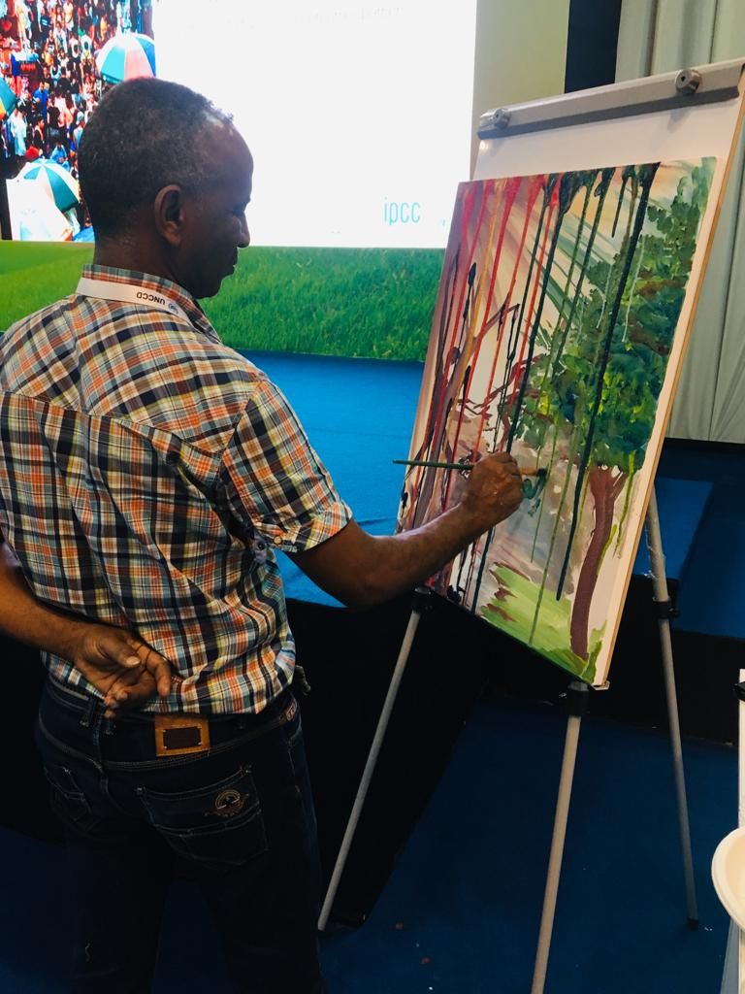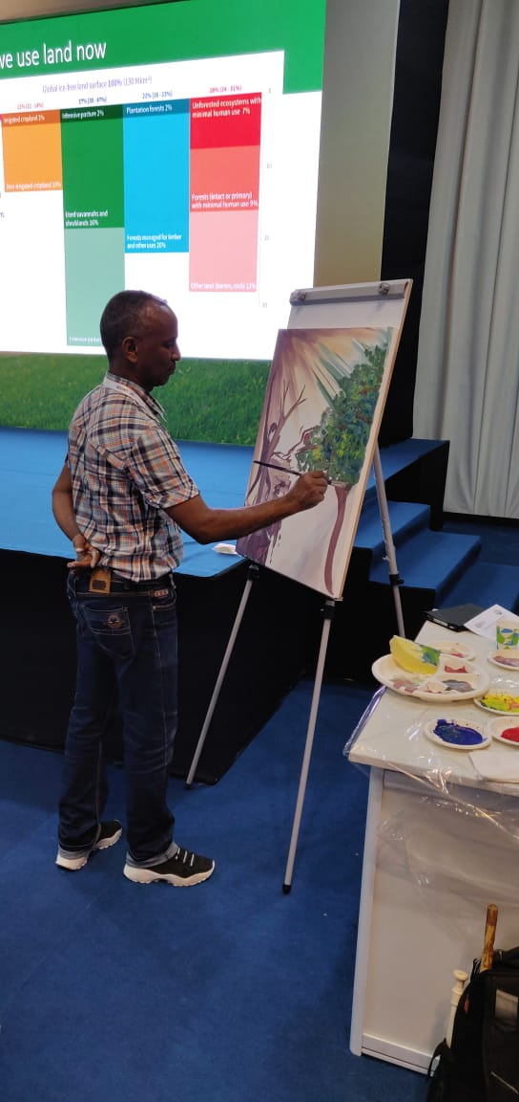

The essence of the discussions of the Science Day sessions were captured on canvas by noted Eritrean artist, Habteweld Misgina. Mr.Misgina synthesised the information and ideas raised, through his paintings and poetry, providing the group with new perspectives on the intrinsic connections between humans and nature.

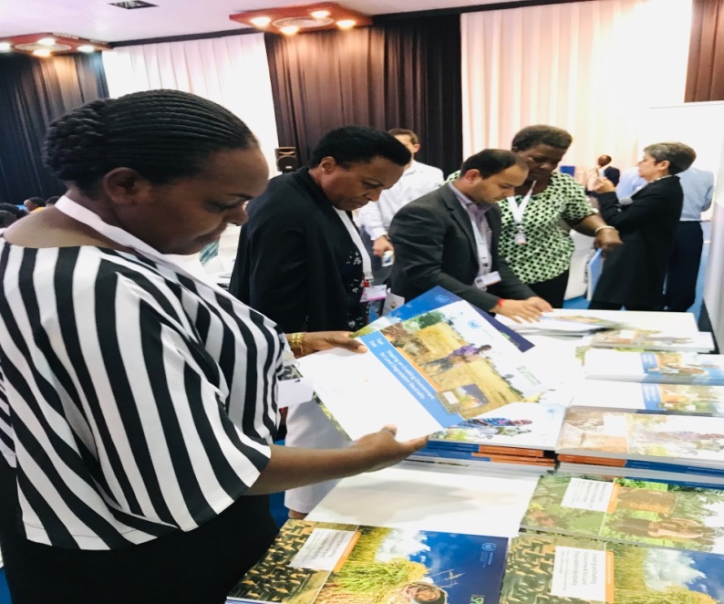
Guests at the Science Day

Highlight 2: The GEF Evening
The day was concluded with an evening reception hosted by GEF where UNCCD Deputy Executive Secretary Pradeep Monga made an address, saying the significance of the GEF to the UNCCD’s implementation at country level.
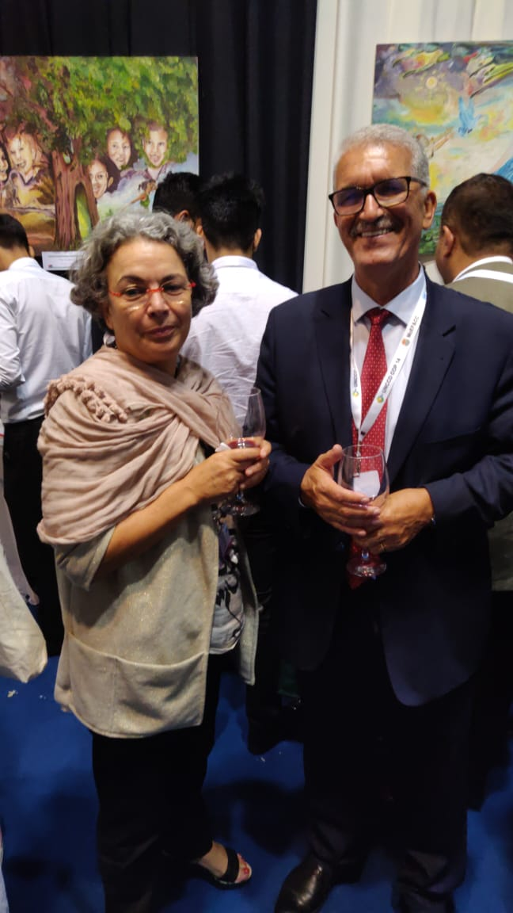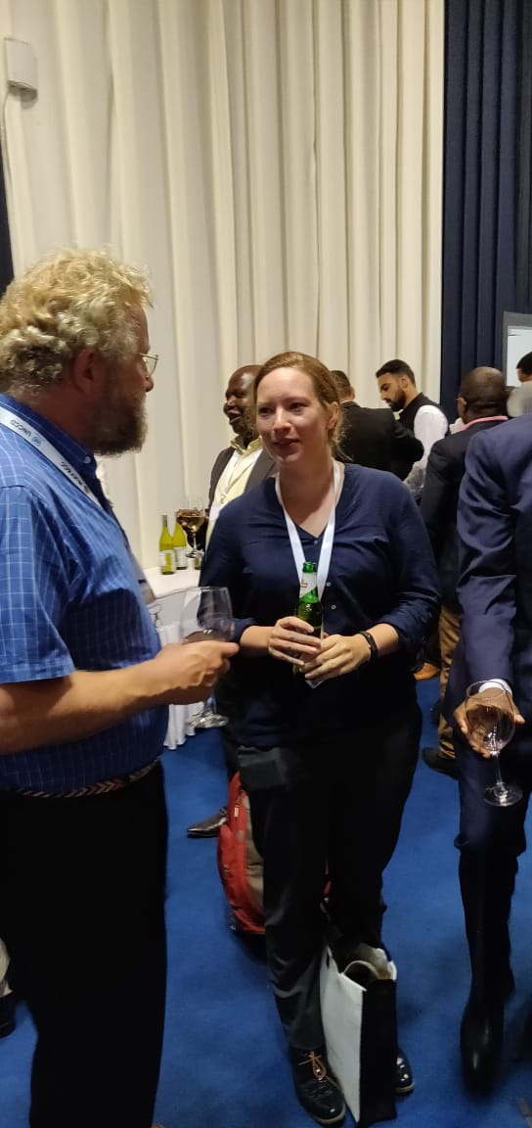
Guests discussing the Science Day sessions at GEF cocktails at Rio Conventions Pavilion

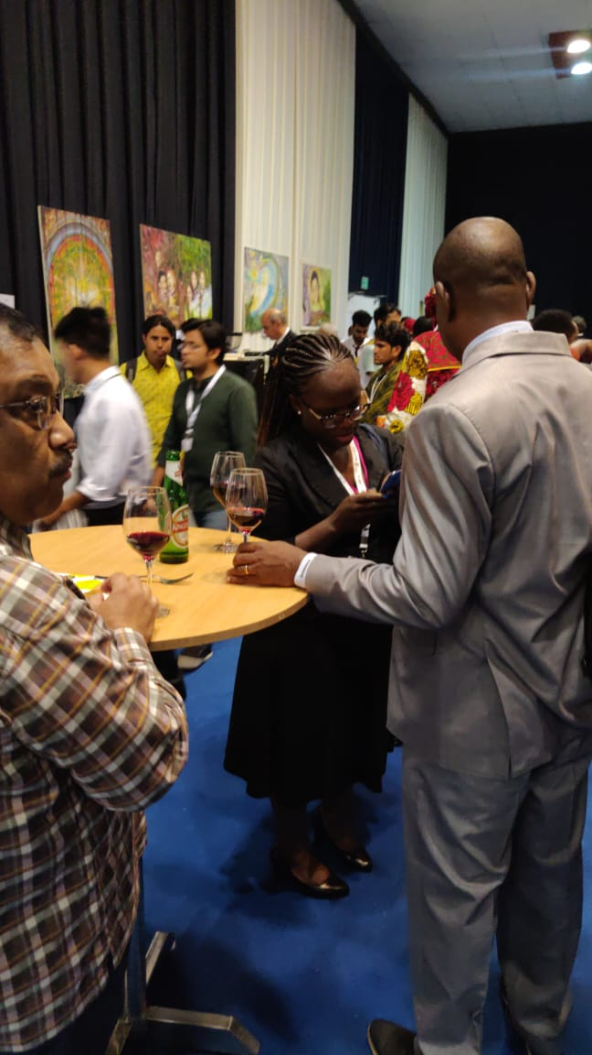
After the deliberations of Science Day, guests at the GEF Cocktails at Rio Conventions Pavilion

